Setting up LSUSHSC email for Android (Galaxy Nexus)
Note: Disregard instructions if an Airwatch profile is installed
Step 1:
Select the Email Icon and then select “Add Account”

Step 2:
Enter your LSUHSC email address and password and select “Manual setup”
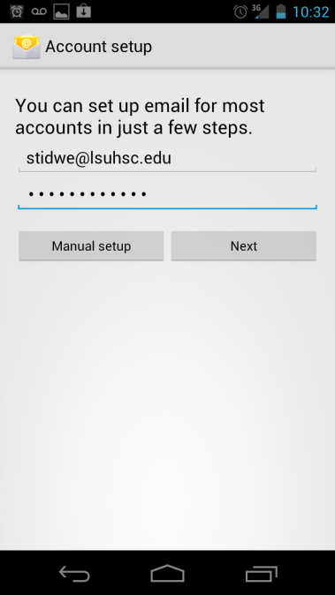

Step 3:
Domain\Username: lsumc-master\your username
Password: your password for email
Server: sh-mail.lsuhsc.edu
Check the box that says “Use secure connections (SSL)”

After these fields are filled out, select “Next”

