Connecting To the Secure Wireless from an Android Device
Guide made using a Samsung Galaxy Nexus (Android 4.0)
Note: Disregard instructions if an Airwatch profile is installed
Step 1:
Go to settings
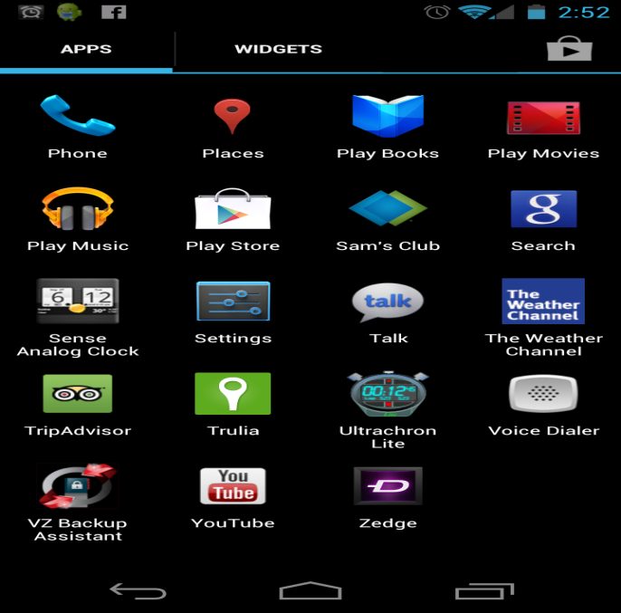

Step 2:
Turn on wireless and connect to LSUHSCS
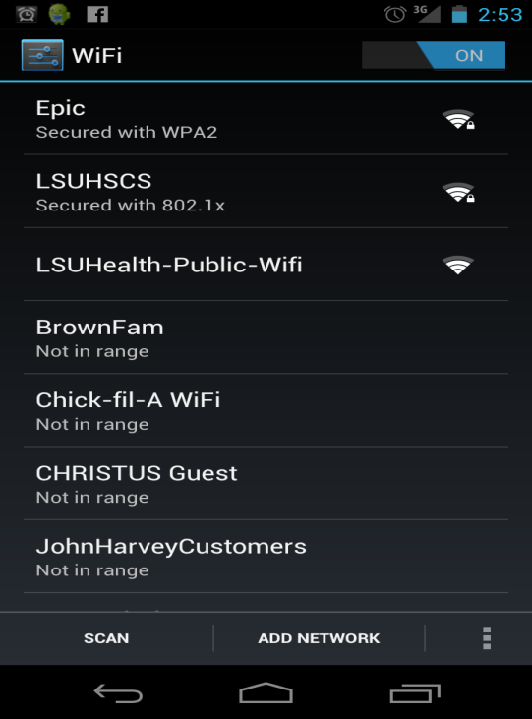

Step 3:
Type in your username and password in their respective boxes and then press “Save” (Note: username might be called “Identity” on some devices)
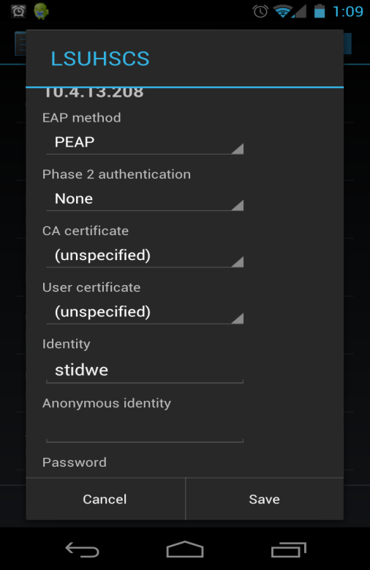

SUCCESS!!!!! You are now connected.
