How to remove an exchange account/email account that was setup on Iphone/ipad
Note: Disregard instructions if an Airwatch profile is installed
1. On the iPhone, go to Settings
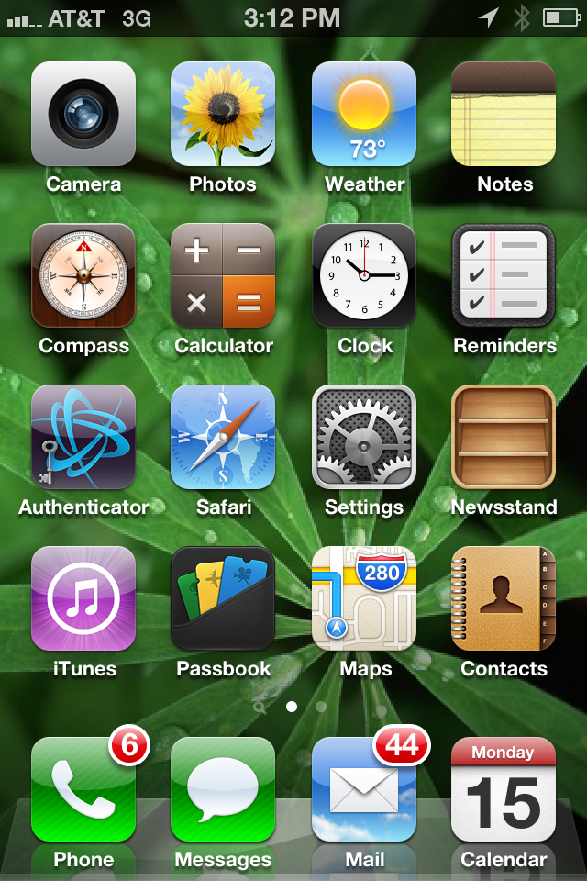
2. Go to Mail, Contacts, Calendars
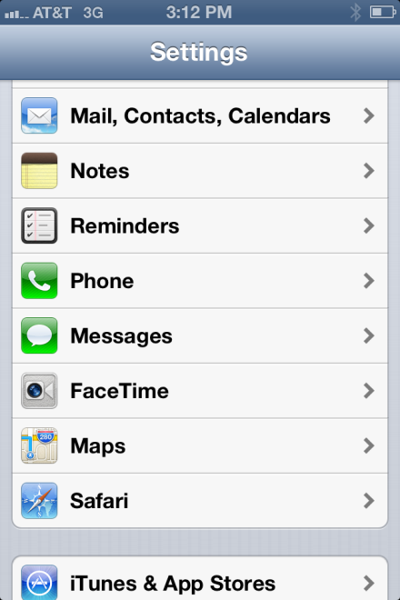

3. Click on the Exchange account
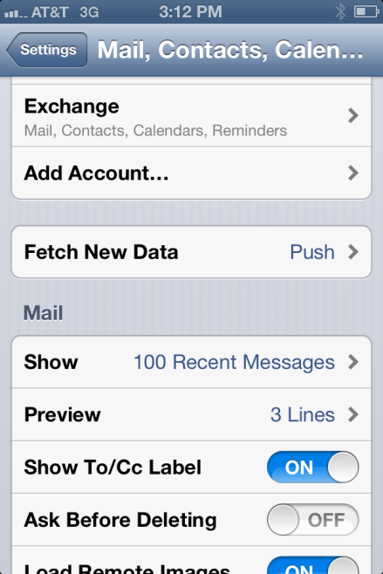
4. To change/update the account click the exchange account & on the next screen update the password field with your current password. Otherwise to delete the account go to step 5.
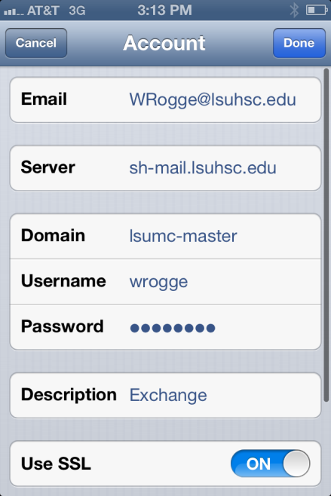

5. Scroll towards the bottom and click on “Delete Account”
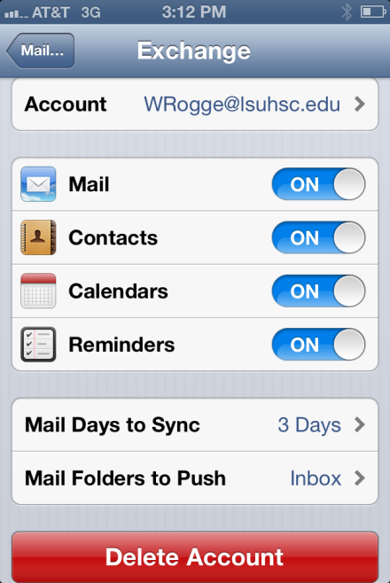
6. Finally, you’ll get the Delete Account warning, click Delete Account to finish.
